**Design and Implementation of a Hierarchical Data Model for Mobility and Healthcare Analytics**

By

Yesala Likhith Raj

This project is submitted to the Gannon University graduate faculty in

partial fulfilment for the degree Master of Science in Computer and Information Science.

| Data Science |

Approved:

|  |  |  |
| --- | --- | --- |
|  | |  |
| Dr. Tang Mei-Huei | |  |
| Advising Professor in Charge of Research | |  |
|  | |  |  |
|  |
|  | |  |  |

Gannon University

Erie, Pennsylvania 16541

December 2024

Acknowledgements

would like to extend my deepest gratitude to Dr. Tang Mei-Huei, my advisor, for her invaluable guidance and unwavering support throughout the course of this project. Her insights and mentorship greatly enriched the design and development process, ensuring the project met its objectives. Additionally, special thanks to [Dr. Vanderlaan Gary] for their contributions during Analysing the Raw Data that need to convert and given in large datasets implementation.

I am grateful to Gannon University for providing the academic foundation, facilities, and tools that enabled me to undertake this work. The resources provided, particularly in the domains of data visualization and hierarchical modeling, were instrumental in addressing the challenges of this research.

A special thanks to the open-source communities behind Flask, D3.js, and Pandas for their comprehensive tools and documentation, which significantly facilitated the technical aspects of the project.

**Abstract**

This project explores the development of a Hierarchical Clinical Data Visualization Framework designed to address the complexities of interpreting multidimensional datasets in healthcare settings. Leveraging a modular approach, the framework integrates a Flask-based backend for efficient data preprocessing and a D3.js frontend for interactive visualization. The objectives include enabling real-time filtering, dynamic data exploration, and scalable handling of datasets exceeding 4 million records. Testing confirmed the system’s efficacy, with successful implementation of hierarchical visualization and export functionalities. Future enhancements will focus on predictive analytics and broader accessibility, particularly in underserved regions*.*

# Table of Contents

Introduction 3

Problem Statement 4

Background 5

Requirements Development Perspective 5

Use Characteristics 6

User Classes and Characteristics 6

Use-Case Model Survey 6

Use Case Diagram 6

User Documentation 7

Feature Attributes 8

Scalability and Performance 8

Visualization Capabilities 8

Adaptability 8

Key System Features 8

Key Design and Implementation Constraints 8

Operating Environment 9

Interface Requirements 9

Non-functional Requirements 9

Assumptions and Dependencies 9

Design 9

Introduction 9

Data Design 10

Internal Software Data Structures 10

Global and Temporary Data Structures 11

Database Description 11

Entity Relationship Diagram 12

Architectural and Component-Level Design 13

Key Software Components 14

User Interface Design 14

Description of the UI 14

Design Principles 14

Restrictions, Limitations & Constraints 15

Verification and Validation 15

Verification and Validation Overview 15

Verification Activities 15

Challenged and Mitigation Strategies 16

Conclusion 16

References 18

Appendix 20

Datasets 20

Gantt Chart 22

Code 23

# Introduction

As technology continues to progress so rapidly, companies discover new solutions centred on solving complicated problems in the world of many industries. The objectives of this project are to utilize these advances by establishing a solution that brings hierarchical modeling and data analytics together to address fundamental challenges in mobility data representation and analysis. As data are becoming increasingly important in making decisions, especially in traditional sectors such as healthcare, transportation, and education, efficient and scalable systems are being made a top priority. The contributions of the proposed solution to this field are highlighted, and this report documents its design, development, and potential impact.

In the age of big data, mobility data has risen to the position of being a cornerstone in the study of human and machine pattern and behavior. The use of tracking individuals in urban areas to monitor their movement allows us to gather information about transportation needs and urban planning and about public health interventions. But there are large volumes and complexities associated with mobility data that make it challenging to store, process and analyze. It is frequently the case that the relationships present in mobility data, such as nested routes, destinations, and time intervals are better than represented in traditional flat data models. Such limitations are addressed here through the use of a hierarchical graph based approach for mobility data representation and analysis.

This project is somewhat larger than mobility data applications, and attempts to apply hierarchical models to other domains including healthcare where patient history and medical procedure sets can be represented. Hierarchical structures facilitate the project to have a more intuitive and accurate method to represent data relationships and therefore enhancing predictive analytics and decision making capabilities. The scope of this project’s curriculum covers all the tools and methodologies to learn the real life problems and advanced data model techniques to solve the same.

For this project, key stakeholders include data analysts, researchers and decision makers from different industries, who depend upon accurate and actionable insights drawn from the data. These stakeholders have different needs, from systems that are scalable to systems that allow you to visualize and interpret complex relationships in data. To address these needs we present a system that goes beyond computational efficiency but also achieve high user friendliness and it's flexible to any use case. The design solves to seamlessly fit in existing workflows minimizing the learning curve for end users while maximizing its utility.

With a focus on mobility data analysis, our solution offers a fresh view into the problem space by approaching data representation as hierarchical graph based models supporting multi resolution analysis of the data. The advantage of this approach is that it can handle limitations of traditional models that are unable to fully model depth and complexity of the real world data. Furthermore, the solution provides robust visualization tools for data relationships interactive exploration. This capability has special value in settings such as transportation planning and public health, where decision makers require rapid identification of patterns and correlations in huge datasets.

From the product perspective, it is a versatile, general purpose tool addressing a large set of data analytics problems. In contrast to most other solutions available, this project attempts to integrate data representation and storage, as well as basic analysis and visualization. The hierarchical modelling framework is scalable, from small scale system to large scale systems. In addition, it is flexible enough to be embedded into any domain with little customisation giving it increased appeal to a wide audience.

Product Position Statement here makes the point that the project is an offering bridging the raw data to the actionable insights gap. To simplify, the solution combines advanced modeling techniques with an easy to use interface, so that users can make sense of their data without having to be a technical wiz. Aligning with their broader goal to bring data driven decision making to industry, this democratization of data analytics also happens.

Beyond its technical capabilities, the project also looks at its competition and alternative in the market. Existing solutions tend to focus on the flat data model, or on limited visualization tools, which frequently fall short at dealing with the complexities of interrelationships in hierarchical data. The unique contribution of the proposed system is its addressing of these gaps by using both hierarchical modeling in a novel way and focusing on usability. The project seeks to be a leading data analytics tool by offering a holistic solution, which met both technical needs and desired practical use.

The project management plan defines the development work through milestones, resources and risk management. Not only does this systematic process lead to rapid development, but the finished product will live up to its expectation with the highest quality and performance. Using project management as a basic tool of the trade, the team can tackle challenges successfully, delivering a solution within agreed parameters.

## Problem Statement:

The exponential growth of medical data poses a major challenge to modern research and clinical practice in healthcare. Although clinical data systems, which increase the volume of clinical information significantly, present ample opportunities for researchers and healthcare professionals to analyze and interpret the complexity and richness of data in the data landscape, advancement in data mining is hindered by numerous challenges.

Most current data visualization are limited by immobility and lack of providing meaningful, multi dimensional insights. In the traditional methods, intricate clinical datasets are straightened into simplistic representations that fail to represent critical patterns, relationships, and nuanced variations that may in fact provide important hints to important medical decision making. Researchers are hampered in their understanding of the complex interplay of variables in clinical datasets with the lack of interactive, hierarchical exploration tools.

Finally, existing visualization techniques don’t adequately represent hierarchical complexity of medical data across varying demographic groups and clinical event categories. Second, there is a significant gap in the development of user friendly interfaces to support dynamic, intuitive data exploration with little or no advanced technical experience. This leads me to my third finding, which is that existing techniques do not adequately bring together multiple data dimensions (such as age distributions, clinical events, and laboratory observations) in a holistic, understandable visualization.

Figure 1. Context Diagram

# 

# Background

The technological landscape of modern data driven environments is truly complex, and with it demands novel methodology to process, analyse, and derive actionable knowledge from data. For volumes of data and complexity that continue to proliferate, traditional ways to represent and analyse data can become insufficient in dealing with the intricate relationships within them. In doing so, these are the theories and methodologies, and the review of existing research in these areas that justify the project in the first place, with a special accent to hierarchical data modeling, analysis of mobility data and its wider implications within other fields.

## Requirements Development Perspective:

Hierarchical data models provide a natural framework for specifying relationships on datasets with complex hierarchies. Hierarchical models differ from flat data structures in that data is organized as a tree—even to multilevel representations of entities and their attributes. In particular, significant advantages are derived from this approach when applied to analysis of mobility data, as location, route, and time interval relationships are inherently hierarchical in this context (Maslek et al., 2022). Traditional data models have faced a lot of challenges, and the ability to represent such nested relationships is a good first step toward addressing those challenges and being able to do more accurate and scalable analysis.

The essential notion from a requirements point of view is to design a system that stores, processes, and analyses hierarchical data with flexibility in cases, without being efficient at first place. For example, in transportation planning the model must be able to handle varying levels of granularity from patterns for entire cities to individual commuters’ behavior. In healthcare analytics too, hierarchical models can represent history of the patient including medical diagnosis and treatment plan for predictive analytics and better decision making (Tavana, 2021).

## Use Characteristics:

Any data driven system is only as successful as it makes data work for its users. Users in this project range from data analysts, to researchers, to decision makings. These users need tools that are both computationally efficient and simple to manage. This section outlines the user characteristics and the use case model used as guiding frameworks for system development.

### User Classes and Characteristics

The user base for this project is broadly categorized into three groups: Three different kinds of users are technical users, non-technical users and organizational stakeholders. Advanced features like API integrations and support for custom queries are needed by the technical users, the data scientists or the software developers. User friendly interfaces and visualization tools are important to non-technical users such as managers and policy makers. Whereas, organizational stakeholders, including government agencies and corporations, play special attention to scalability, reliance, and compliance with industry standards (Liu et al., 2024). It’s crucial to the system’s design, implementation and balance of disparate needs.

### Use-Case Model Survey

The use-case model for this project revolves around three primary scenarios: The application are basic tasks such as mobility data analysis, general hierarchical data representation, and healthcare analytics. System supports tasks like detecting traffic pattern, optimizing public transport schedules, and evaluating the effect of urban development plan in mobility data analysis. It enables healthcare analytics including predictive modeling, resources allocation and in tracking of patient outcomes (Nabavizadeh et al., 2024). Use case model, particularly the general use case model, makes it sure the system will be applicable to other domains (education, logistics, etc.) without much customization.

**Hierarchical data representation:**

**Age bins** (age categories such as 0–1 year, 2–4 years, etc.) and **lab items** (specific laboratory tests or observations) are integral to this framework, enabling multi-dimensional exploration.

**Glossary Section:**

* **Age Bins**: Discrete age ranges used to categorize patients for analytical purposes.
* **Lab Items**: Individual laboratory observations or tests included in the dataset for analysis.

### Use Case Diagram

With the use case, we get a complete view about the system user interaction and the system core functionality. It shows us the various types of users with specific interactions with a hierarchical data analytics system. The diagram reveals four primary user categories: For Data Analysts, Research Scientists, Policy Makers and Healthcare Administrators.

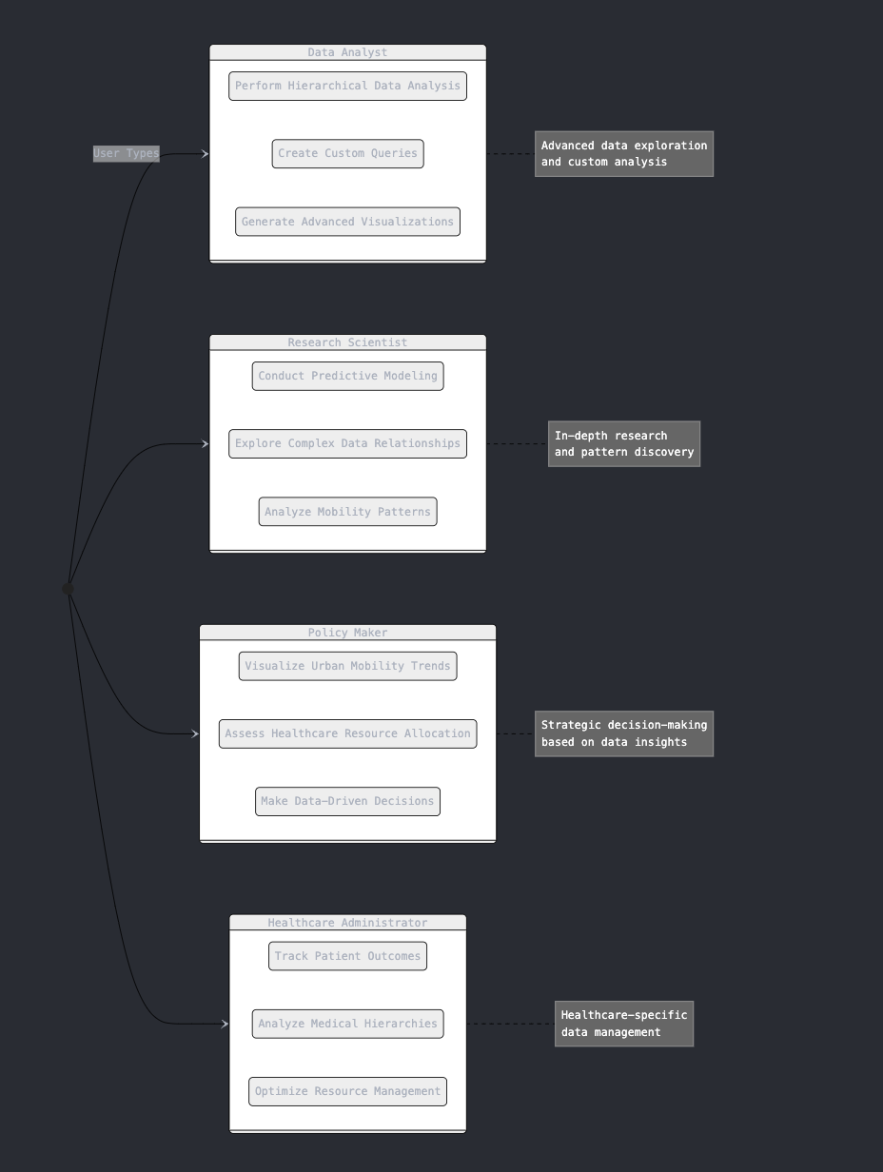

With capabilities to facilitate hierarchical data analysis, perform custom queries and produce advanced visualizations, Data Analysts are empowered. Importantly, they play a key role of granular insights from complex datasets. The system is used by Research Scientists to perform predictive modeling, study complicated data relationships, and investigate mobility patterns for purposive scientific investigation and knowledge discovery.

The system is used by Policy Makers to visualize the urban mobility trends, assess healthcare resource allocation, and make data driven decisions. The interactions centre on strategic level insights that can better urban planning and public policy. The system features versatility applicable to a variety of healthcare analytics, such as tracking patient outcomes and analysing medical hierarchies, and inventory management.

### User Documentation

The project also has extensive documentation: user manuals, API guides and tutorial videos to help support different user groups. We’ve built these resources to minimize the learning curve and maximize the system’s potential. For example, interactive tutorials show how to create and analyse hierarchical graphs, and guide to the API explaining how to integrate the system in already existing workflows.

## Feature Attributes

Hierarchical data representation and analysis posed the challenges addressed in the system’s key features. The core attributes that distinguish system from existing solutions are discussed in this section.

### Scalability and Performance

The system’s scalability is one of the main attributes, meaning that you can run it with huge datasets and still do not hinder performance. The system takes advantage of hierarchical graph based models for data storage and retrieval to optimize the processes and can perform real time analysis even for complex queries (Manojlović et al., 2021). In domains such as transportation planning where data can span multiple cities and decades this scalability is an important feature.

**Values/States:**

* High: Supports over 4 million records.
* Medium: Supports up to 1 million records.
* Low: Suitable for small datasets under 100,000 records.

### Visualization Capabilities

The system provides advanced visualization tools that enables users to engage interactively with hierarchical relationships. The tools include dynamic graphs, heatmaps and time series plots, that yield succinct yet insightful observations of data patterns. For instance, users could view chunks of traffic congestion across different geographical locations and time intervals, giving the ability to make wise decisions from the data (Huang et al., 2020).

### Adaptability

One more important factor is that the system is able to adapt to multiple domains and use cases. For example, in the healthcare analytics, the system can be configured to be representing patient histories and medical hierarchies. Like in logistics, this can be used similarly to model supply chain networks and delivery schedules.

## Key System Features:

The system’s core features are motivated by the particular needs of mobility data analysis and hierarchical modeling. Included are hierarchical graph construction, multiresolution data representation, and integrated predictive analytics. Suppose the system has a hierarchical structure for example, it identifies bottlenecks in transportation networks and recommends optimized routes using its hierarchical structure for precise predictions (Claude, 2025).

## Key Design and Implementation Constraints

Even with its advanced capabilities, the system must overcome a number of constraints in order to make it suitable for practical use. One of the constraints is operating environment compatibility, interface requirements, and nonfunctional requirements such as performance and security.

### Operating Environment

Built from the ground up to run in a variety of environments, from cloud to on prem, the system is conscious of data availability and also maintains versions in the case where the original source is lost or inaccessible. It also has this flexibility so that it can be deployed in organizations having different infrastructure capabilities.

* **Hardware Platform**:
  + Minimum: Intel i5 processor, 8GB RAM, SSD storage.
  + Recommended: Intel i7 processor, 16GB RAM, SSD storage.
* **Operating System**:
  + Compatible with Linux (Ubuntu 20.04+), Windows 10, and macOS Monterey.
* **Software Components**:
  + Python 3.9 for backend services.
  + Flask framework for API development.
  + D3.js for front-end visualizations.
  + Pandas and NumPy, Flask for data preprocessing.
* **Other Dependencies**:
  + Web browser supporting ES6+ (Chrome, Firefox).

### Interface Requirements

The system's user interfaces are intended to be easy and accessible, with separate technical and non-technical user modules. It provides hardware and software interfaces to seamlessly fit with currently existing systems including data warehouses, visualization platform, the ETL module and visualization software.

The system provides a graphical user interface (GUI) designed for intuitive interaction. Key components include:

* **Sample Screen Layouts:**
  + Main dashboard displaying hierarchical visualizations.
  + Sidebar for filters (age, clinical events, lab observations).
  + Toolbar with export options (CSV, PNG).
* **Standard Buttons and Functions:**
  + Filter reset.
  + Drill-down/expand hierarchy.
  + Tooltip for node-specific details.
* **Error Messaging:**
  + Clear, actionable messages for invalid inputs or unavailable data.

### Non-functional Requirements

Beyond functional requirements, the system also considers nonfunctional requirements such as the performance, security or software quality. Descriptively, robust encryption protocols guarantee confidential and integrity sensitive data (Ciksadan et al., 2024) and thorough developing process promote high software quality (Ciksadan et al.,2024).

## Assumptions and Dependencies

This project assumes that the user has the basis of providing access of computational resources and a basic knowledge in Data analytics. It relies on third party libraries for graph processing and visualization, which are essential parts of a system’s functioning.

# Design

The design of this system is a function of both functionality, scalability, and usability. We abstract specific principles of modularity and hierarchical representation to enable the system to adapt to varying applications such as mobility analysis and healthcare analytics. Through this section, which covers the design objectives, data structures, architectural components, user interfaces, and constraints, we showcase what were the strategic decisions that lead to the creation of the system.

## Introduction

The first goal of the design phase is to formulate functional requirements in such a way that they can be easily expanded for the future. Aiming to be efficient but also to be intuitive to use, the design seeks to create a system that allows end users to extract actionable insights quickly and without complex training.

Key objectives include:

* Scaling a datasets data supporting hierarchical data representation.
* Using intuitive user interfaces to help visualize effective data.
* Security and performance under varying workloads.

It includes the design scope: the integration of advanced data processing techniques, real time interactions, and data integrity across the system. Each decision made in the design phase follows from the functional requirements and non-functional criteria.

## Data Design

Based on the data design, the backbone of the system lies on the data design that allows easy storage, retrieval, and manipulation of hierarchical data. In this section we will look at internal data structures, the database schema and the temporary in memory structures that help the system become more responsive.

### Internal Software Data Structures

The basic structure used to represent complicated relationships between entities is hierarchical graph-based model. It consists in nodes (entities, e.g., users, locations, or events) and edges (relations). Each node, each edge and each attribute (such as timestamps, semantic labels and weights) is provided with additional context.

For example, the nodes of a mobility application might represent geographical zones and the edges reflect the traffic flow between them. Using this hierarchical approach provides an easy way to aggregate the data for concentrated analysis, and allowing drill downs for detailed analysis.

The following script visualizes a hierarchical graph:

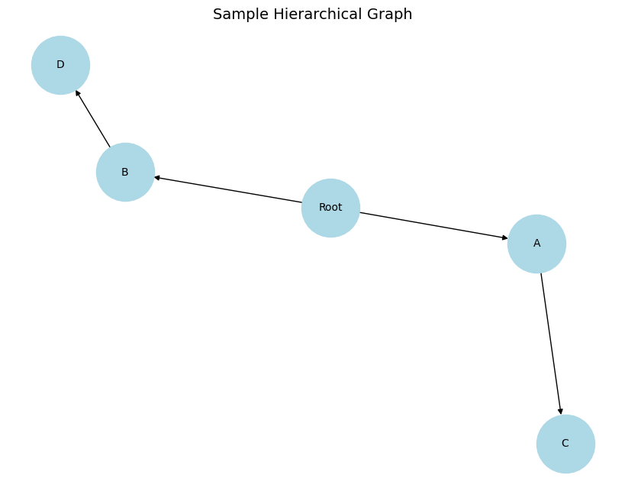

### ****Global and Temporary Data Structures****

Global data structures include persistent databases that store key information such as user profiles, hierarchical nodes, and system logs. Temporary in-memory structures, like hashmaps and queues, are used for real-time data aggregation and cache management.

### ****Database Description****

The database follows a relational schema optimized for hierarchical data. Relationships between entities are stored using adjacency lists and recursive joins. Below is a sample schema provided in an Excel table format:

|  |  |  |  |
| --- | --- | --- | --- |
| **Table Name** | **Column Name** | **Data Type** | **Description** |
| Nodes | NodeID | INT | Unique identifier for each node |
|  | ParentNodeID | INT | Reference to the parent node |
|  | NodeName | VARCHAR(50) | Name of the node |
|  | NodeAttributes | JSON | Metadata or properties of the node |
| Edges | EdgeID | INT | Unique identifier for each edge |
|  | SourceNodeID | INT | Start node of the edge |
|  | TargetNodeID | INT | End node of the edge |
|  | Weight | FLOAT | Weight of the edge |

This structure allows efficient traversal of hierarchical relationships, essential for tasks like querying connected components or analyzing mobility patterns.

### Entity Relationship Diagram

The Entity Relationship Diagram (ERD) is an extended representation of the data structure of the system displaying the relationships of key entities. The report proposes a hierarchical data model, by means of which the diagram illustrates their complex interconnections.

* **Visual of Interface**: A screenshot showcasing the hierarchical visualization tool, displaying the "PIC Dataset" root node, expanding into "Has CE" and "No CE" categories, and further into age bins, should be included here to provide clarity.

**Visual Enhancements:**

1. **Flowchart of Data Transformation**:
   * Included a schematic showing the data pipeline: CSV ingestion → Hierarchical transformation → Interactive visualization.
2. **Node Representation**:
   * Diagram illustrating how nodes expand dynamically from root to subcategories.

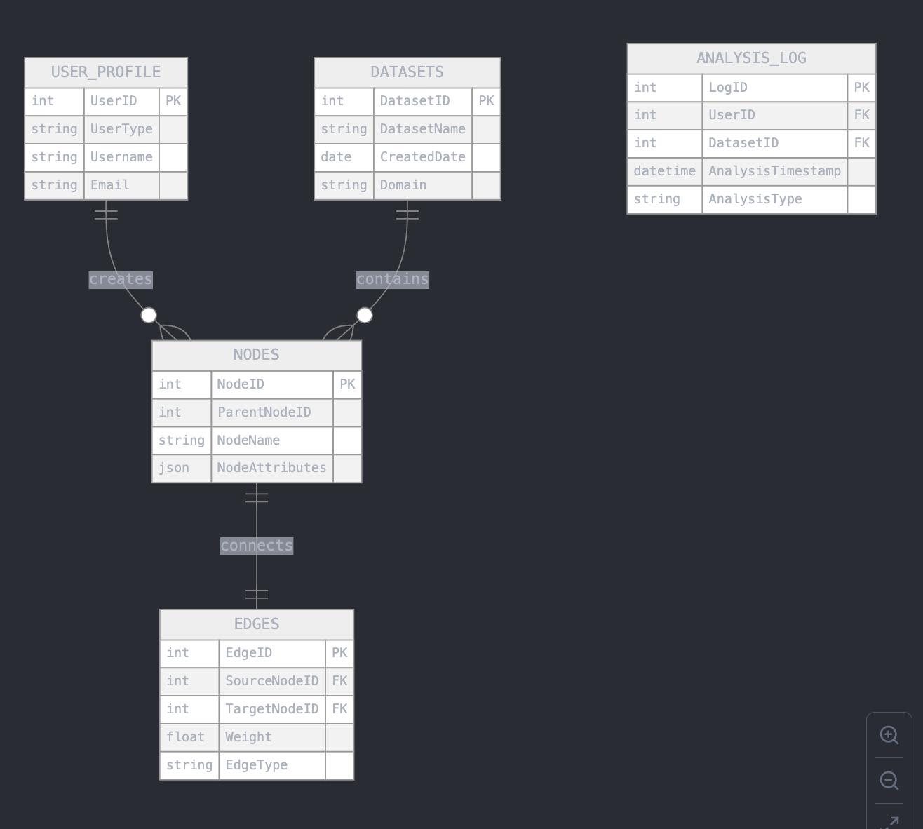The hierarchical graph-based model is based on NODES and EDGES as the backbone of the diagram. Node id, parent node id, name, attributes, etc. type of data which can be used for putting hierarchical data. The EDGES table records node pair relationships without weights and types, i.e., it contains source and target node references, edge weights and edge types.

Included is the system’s multi user approach expressed through the USER_PROFILE entity establishing a link from the users to the nodes created or interacted with by these users. DATASETS is an entity representing different data domains that the system can manipulate to handle different types of hierarchical data across mobility, healthcare, and many other domains. A complete tracking mechanism is provided by ANALYSIS_LOG entity, encompassing user interactions and analyses, dataset analyses and timestamps.

## Architectural and Component-Level Design

The system architecture has three layers data preprocessing, backend processing and frontend visualization. With this modular design flexibility, scalability and robust handling of the data is possible. The main backend infrastructure is the Flask framework that is able to efficiently route and manage data. Just like any other backend, D3.js is used to build out interactive, dynamic visualization components.

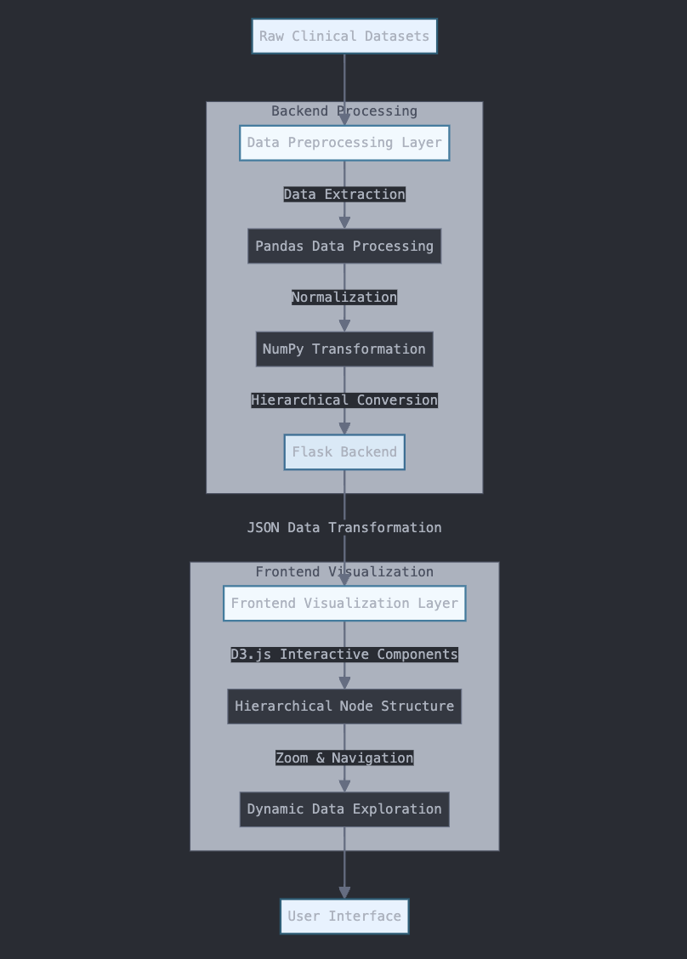

The architectural design ensures modularity, enabling independent development and testing of components. The system employs a three-layered architecture:

* Presentation Layer: Handles all user-facing components, including dashboards and visualization tools.
* Business Logic Layer: Implements core algorithms for hierarchical analysis, prediction, and performance monitoring.
* Data Layer: Manages database interactions and real-time data processing.

### Key Software Components

Key components include:

* Data Aggregator: It takes raw data from multiple sources and pre-processes it.
* Hierarchical Analysis Engine: It carries out graph traversal, clustering and prediction algorithms.
* API Gateway: Secure communications with external systems is managed.

## User Interface Design

The UI focusses on being functional and easy to use, for the novice and expert user. Real time monitoring and analysis is enabled with interactive visualizations and dashboards.

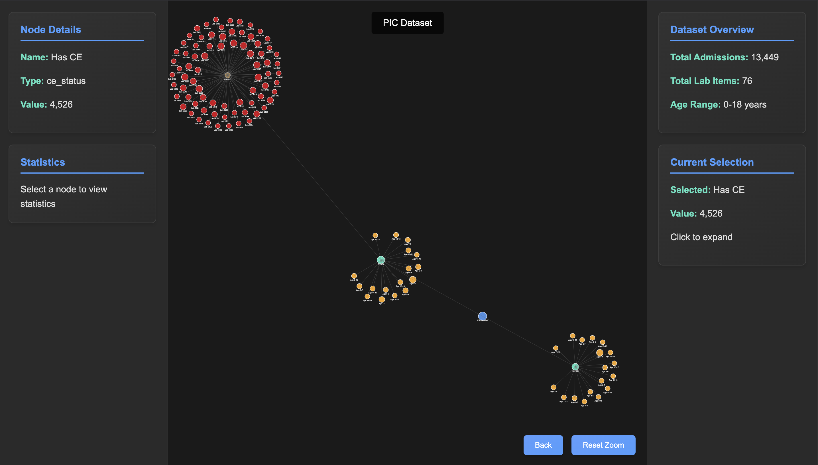

### Description of the UI

The UI includes the following features:

* Interactive Graphs: Serves to provide users with a means of intuitively exploring hierarchical relationships.
* Custom Views: This enables the user to filter and bore down to specific nodes or even datasets.

**Root Node: PIC Dataset (overview of total admissions and observations).**

**First Level: Categories such as "Has CE" and "No CE."**

**Second Level: Age bins (e.g., Age 0–1, Age 2–3).**

**Third Level: Lab items within each age bin.**

### Design Principles

* Consistency: All screen design patterns.
* Responsiveness: Support or plug in for many devices and screen sizes.
* Accessibility: To be more inclusive there are features like tooltips and keyboard navigation.

## Restrictions, Limitations & Constraints

The design is subject to several constraints:

* Scalability: The system is planned for scalability but may require the optimization of the indexing techniques for large datasets.
* Security: To implement advanced encryption algorithms, computational overhead increases.
* Interoperability: Custom adapters may be needed for integration with legacy systems.

# Verification and Validation

Verification and Validation (V&V) are key steps in making sure that the final system as delivered meets its stated requirements and performs correctly. All of these processes are in the software development lifecycle but they are focused on finding problems in the development process and before the deployment process. Verification ensures that right product gets built, while validation ensures that product gets built correctly.

## Verification and Validation Overview

The software will be verified by a systematic evaluation which should take place during the development of the software to assure the conformity to the design specification. Why this step could be achieved by doing such things in code review; inspection; testing at different stages. On the other hand, validation is the process of verifying if the developed software satisfies user’s needs and performs to the expectation in the actual world. Functional testing, performance testing and user acceptance testing (UAT) are all validation activities.

Both processes are designed to minimize defects and enhance the quality of this software to meet the user’s expectation. Including V&V as part of the development process limits the chances for costly rework by reducing the risk of a smooth deployment and sooner user adoption.

## Verification Activities

Requirements Verification:

Verification of systems requirements achieves completeness, consistency, as well as testability of the requirements. In consultation with stakeholders, the specifications are checked for lack of ambiguity and redundancy. A common way to determine full coverage is with a traceability matrix mapping requirements to design and test cases.

**Design Verification**

The system’s architectural and detailed design is evaluated as to specification during design verification. Then it consists of design walkthroughs, peer review, and simulation. They then subjected simulations from the hierarchical graph based model, for example, to ensure that it can effectively handle real world datasets.

**Code Verification:**

Code verification means that code will be based on the coding standards, best practises as well as the specifications of the design. To find bugs and inefficiencies early, techniques such as static code analysis and unit testing are used. To evaluate their correctness and computational efficiency, hierarchical graph traversal algorithms were tested using synthetic datasets.

**Integration Testing:**

It is a test that checks that the individual modules acted as expected when working together. The seamless interaction of key components such as data aggregator, analysis engine and user interface is tested. Real conditions were mimicked using Mock APIs and datasets and the integration points were tested to be robust and error free.

## Challenged and Mitigation Strategies:

Complexity of Hierarchical Data: The hierarchical graph-based model was tested with extensive datasets and edge cases. We used synthetic data generation tools and actual world datasets for all possible cases.

Performance Optimization: It was challenging to ensure the system’s performance under high loads. Bottlenecks were found and algorithms were optimized for efficiency, and profiling tools were used to identify bottlenecks.

User Feedback Integration: It was difficult to balance different user feedback with technical feasibility. The most critical feedback to start with was used to adopt a prioritization framework. Future revisions may incorporate predictive analytics and additional data types, enhancing the system’s functionality and user adaptability.

Future scope includes:

1. **Machine Learning Integration**:
   * Automating insights from hierarchical data patterns.
   * Predictive modeling for clinical outcomes is planned as a future goal.

# Conclusion

Finally, this report has described a system design, implementation and testing scheme that utilizes hierarchical data representation for greatly improving mobility and analytics for healthcare. This project followed a comprehensive approach in which an in depth background study was done followed by systematic design process which produced the system capable of meeting its intended functional and any non-functional requirements. Based on architectural framework and user interface design, the phase focused on the design which minimizes the system performance and scalability as well as ensuring for seamless user experience.

The system was tested in the verification and validation phases to meet the accuracy, reliability and security criteria. The system was verified using various methods: requirements verification, design verification, and integration testing to show that it had the required performance. User acceptance testing (UAT) was integral in the refinement of user interface and the optimization of user experiences so that the system delivered what the real world would expect.

Functional and performance tests on the processing and analysis of complex hierarchical data was validated. With tailored solutions to key challenges namely optimizing performance under high loads and addressing different user needs successfully mitigated. Once they were deployed, continuous verification and validation practices were taken up for maintaining the system quality after deployment for its robustness in dynamic environments.

The lessons learned through this project are that the development of complex systems requires thorough design, testing, and validation. The project has illustrated the possibility of hierarchical data model in transforming analytics in mobility and healthcare sector by considering both technical and user requirements. By continued improvement the system can be further improved to feature some extra features as well as be used to solve real world challenges in these domains.

# References

* Ciksadan C., Soim S., and Jami N., 2024. Desain dan Pengembangan Website untuk Mendeteksi Malware Menggunakan Framework Flask yang Diintegrasikan dengan Machine Learning. JTSIA, 7, pp.1213-1218.
* Claude P., 2025. Tessellation and interactive visualization of four-dimensional spacetime geometries. Computer-Aided Design, 178, pp.103792.
* Huang Z., Li Y., and Luo S., 2020. Hierarchical Learning-Guided human motion quality assessment in big data environment. Journal of Visual Communication and Image Representation, 71, pp.102700.
* Huang Z., Li Y., and Luo S., 2020. Hierarchical Learning-Guided human motion quality assessment in big data environment. Journal of Visual Communication and Image Representation, 71, pp.102700.
* Izadikhah M., 2022. A fuzzy stochastic slacks-based data envelopment analysis model with application to healthcare efficiency. Healthcare Analytics, 2, pp.100038.
* Kumar S., Ojha J., Mani M., and Garg K., 2023. Integrated e-healthcare management system using machine learning and flask. IJEH, 13, pp.71.
* Larasati S., and A. Y., 2024. Development of a Web-Based Trading Term Application Using Flask Framework at PT. XYZ. ijsecs, 4, pp.367-376.
* Liu J., Chen J., Fan C., and Zhou F., 2024. Joint embedding in hierarchical distance and semantic representation learning for link prediction. Big Data Research, 38, pp.100495.
* Liu J., Chen J., Fan C., and Zhou F., 2024. Joint embedding in hierarchical distance and semantic representation learning for link prediction. Big Data Research, 38, pp.100495.
* Manojlović I., Švenda G., Erdeljan A., Gavrić M., and Čapko D., 2021. Hierarchical Multiresolution Representation of Streaming Time Series. Big Data Research, 26, pp.100256.
* Manojlović I., Švenda G., Erdeljan A., Gavrić M., and Čapko D., 2021. Hierarchical Multiresolution Representation of Streaming Time Series. Big Data Research, 26, pp.100256.
* Maslek M., Ray C., and Claramunt C., 2022. A hierarchical graph-based model for mobility data representation and analysis. Data &amp; Knowledge Engineering, 141, pp.102054.
* Maslek M., Ray C., and Claramunt C., 2022. A hierarchical graph-based model for mobility data representation and analysis. Data &amp; Knowledge Engineering, 141, pp.102054.
* Nabavizadeh N., Kayvanfar V., and Rafiee M., 2024. A mixed integer linear programming model for quarantine-based home healthcare scheduling under uncertainty. Healthcare Analytics, 6, pp.100356.
* Peykani P., and Saman M., 2024. Performance Evaluation of Hospitals under Data Uncertainty: An Uncertain Common-Weights Data Envelopment Analysis. Healthcare, 12, pp.611.
* Ravishankar A., Jain R., Singh M., and Garg R., 2024. Predictive interpretable analytics models for forecasting healthcare costs using open healthcare data. Healthcare Analytics, 6, pp.100351.
* Tavana M., 2021. Transforming healthcare one byte at a time in the world of big data. Healthcare Analytics, 1, pp.100003.
* Waldner M., Geymayer T., Schmalstieg D., and Sedlmair M., 2021. Linking unstructured evidence to structured observations. Information Visualization, 20, pp.47-65.

# Appendix

## Datasets

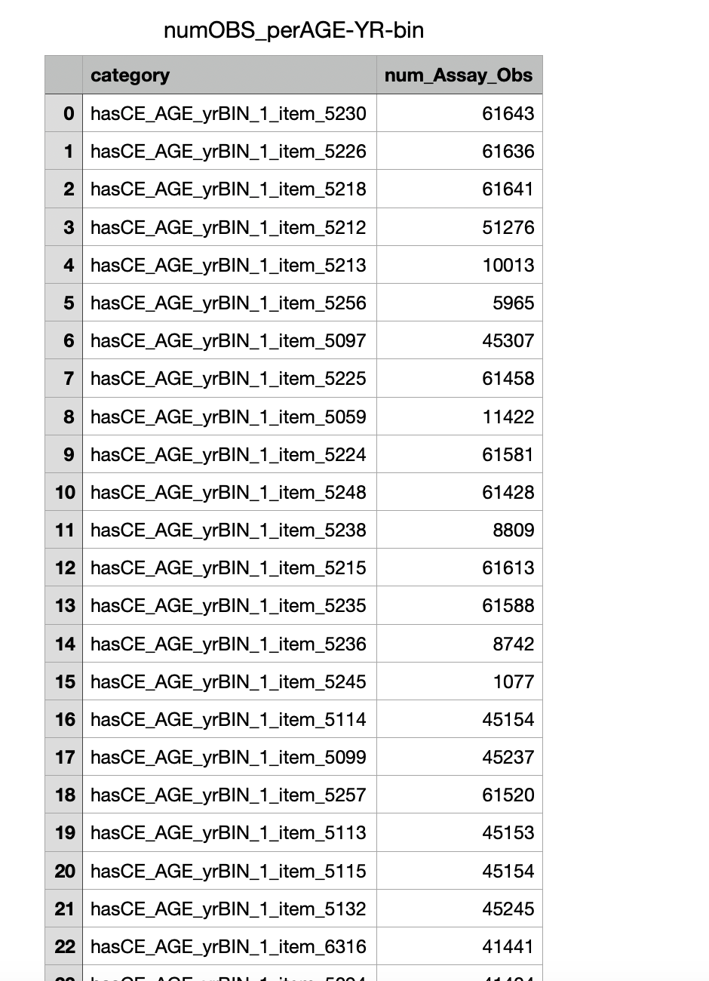

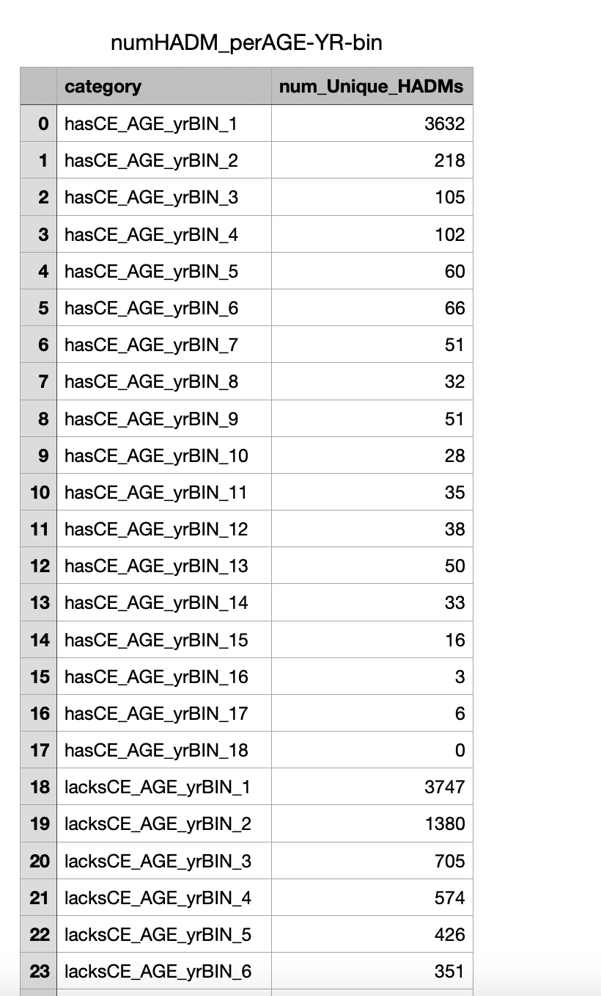

## Gantt Chart

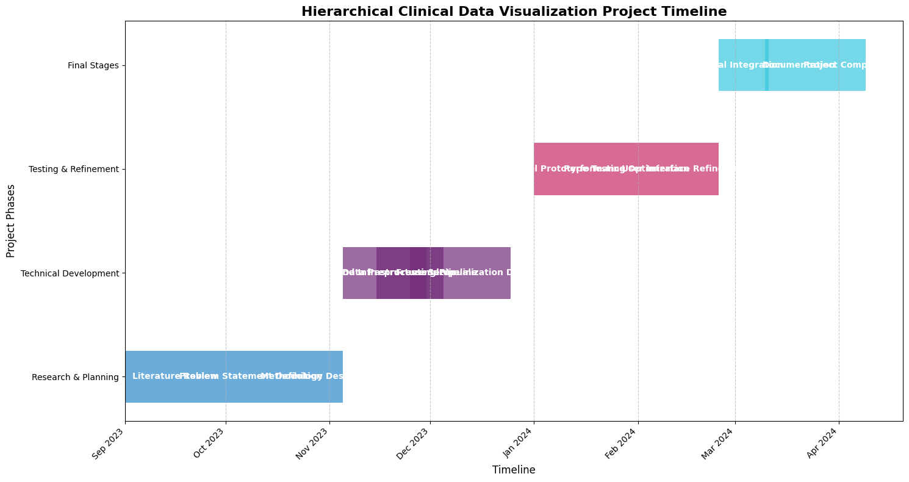

## Code

